DEEPANSH
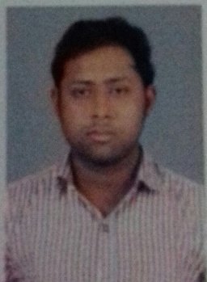
deepanshsaxena1@gmail.com
Mob.7037329333
CAREER OBJECTIVE :
I would like to be a part of a company like your where I will utilise my subject knowledge into practical field
PROFESSIONAL QUALIFICATION:
- Pursuing MBA (2015-2017)from AKTU university
- Specialization finance
- Minor in Hr
ACADEMIC QUALIFICATIONS :
- B.com passed from mjpru in 2015
- Intermediate passed from CBSE. Board 2012
- High school from CBSE board in 2010
INTERNSHIP:
- Two month internship in sharekhan Pvt. Ltd in finance at bareilly

TECNICAL SKILLS:
- MS office
- Basic knowledge of tally 9.ERP
PERSONAL INFORMATION:
Father’s name : Mr Mukesh Saxena
Date of birth : 16-10-1994
Gender : Male
Religion : Hindu
Marital Status : Unmarried
Nationality : Indian
Language known : Hindi & English
Hobbies : Travelling and lisning music
Strength : confidence & hardwork

Address : 706.prem nagar vishnupuri gali no.1 bareilly u.p
DECLARATION :
I declare that all the above particulars are true, complete and correct to the best of my knowledge and belief

DATE
PLACE
DEEPANSH

